­­­­

**MANAV RACHNA UNIVERSITY**

**Computer Science and Technology**

**SCRIPTING LANGUAGE**

**Mini-Project**

**ON**

**Tour and Travels Project**

Submitted To: Submitted By:

MUKUL SINGH(32)

Deepak Rana(15)

Saurabh Chahal(45)

**SUBJECT :- SCRIPTING LANGUAGE**

Faculty Name:

Title of the Project: Travelix - Lets Travel(A tours and

travel online portal)

Team Members Details:

|  |  |  |
| --- | --- | --- |
| Roll No | NAME | DESCRIPTION |
| 2K17CSUN01132 | Mukul Singh | B.TECH CSE 3C |
| 2K17CSUN01115 | Deepak Rana | B.TECH CSE 3C |
| 2K17CSUN01145 | Saurabh Chahal | B.TECH CSE 3C |

**OBJECTIVE:** Faster processing time and more accurate data for travel requests and refund in case of cancellation. Major technological upgrades to the current travel system.

**SCOPE:** The purpose of this project is to provide the complete information about the vehicles available for a tour. Customer visits the site and enters the place from where to where he wishes to travel. He also provides the date as when he would like to travel. Then he sends these details to the travel and tourism agency. The employee of travel and tourism agency receives the mail and check which vehicle is available for that day and reverts back to the customer along with the quotation. If the customer agrees for any one of the quotation, he can reply back along with agreed quotation.

**TECHNOLOGY:** PHP and JAVA SCRIPT

**About SUBJECT:**

A scripting or script language is a programming language that supports scripts — programs written for a special run-time environment that automate the execution of tasks that could alternatively be executed one-by-one by a human operator. Scripting languages are often interpreted (rather than compiled). Primitives are usually the elementary tasks or API calls, and the language allows them to be combined into more complex programs. Environments that can be automated through scripting include software applications, web pages within a web browser, usage of the shells of operating systems (OS), embedded systems, as well as numerous games. A scripting language can be viewed as a domain-specific language for a particular environment; in the case of scripting an application, it is also known as an extension language. Scripting languages are also sometimes referred to as very high-level programming languages, as they operate at a high level of abstraction, or as control languages, particularly for job control languages on mainframes.

In this course we have learnt about Front- end Development including languages like HTML 5, CSS, JavaScript and little Backend involving PHP under the supervision of our Faculties.

**Mini-Project: Travelix- Lets Travel**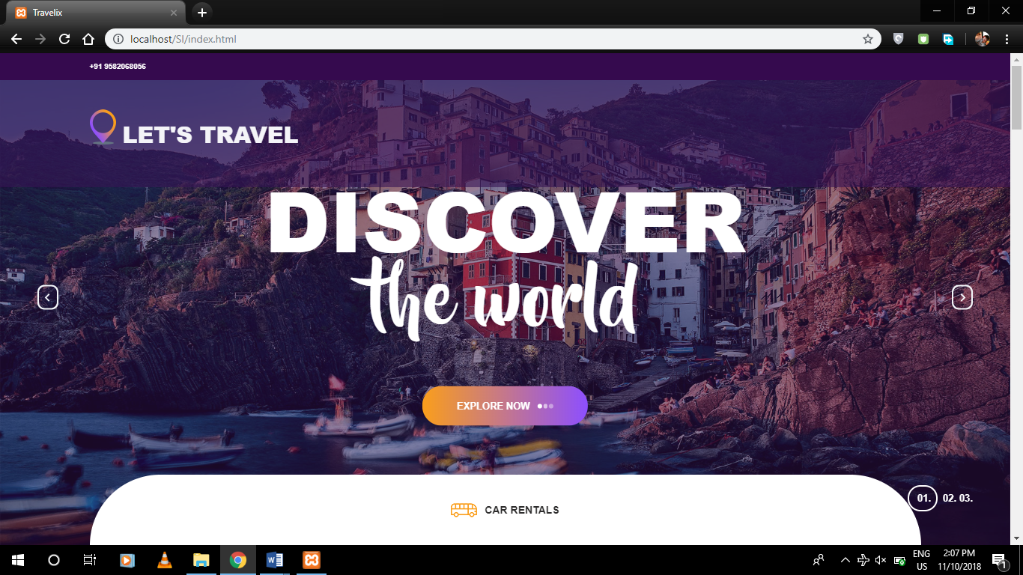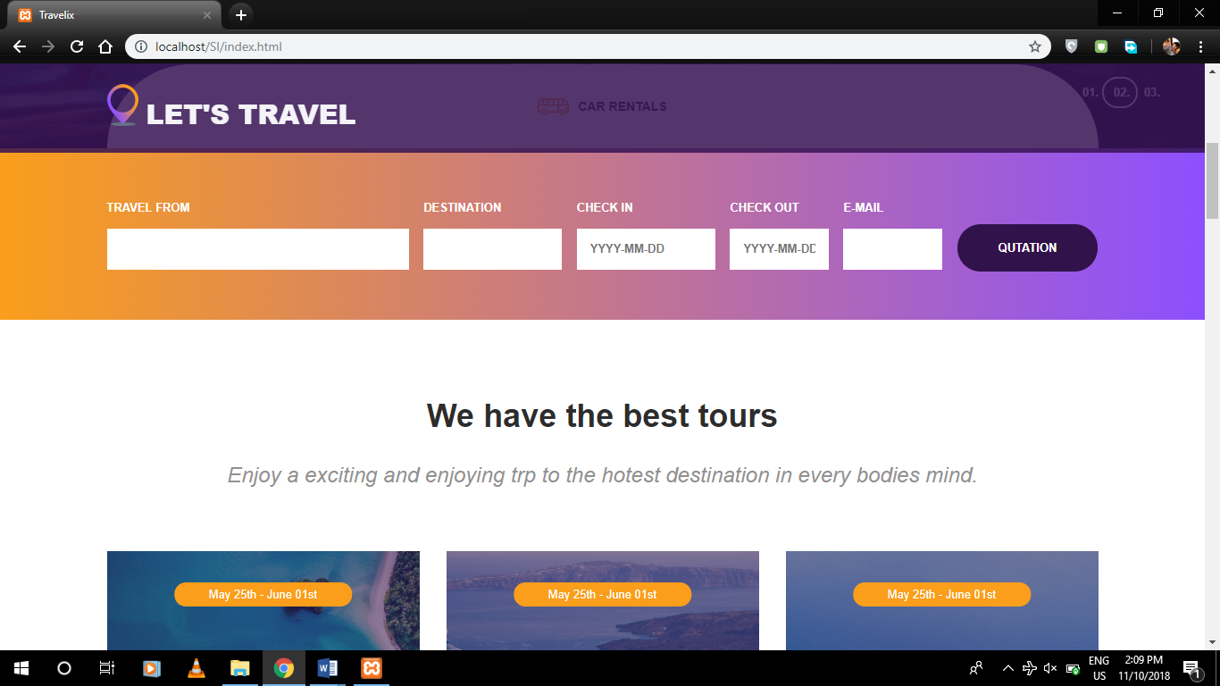

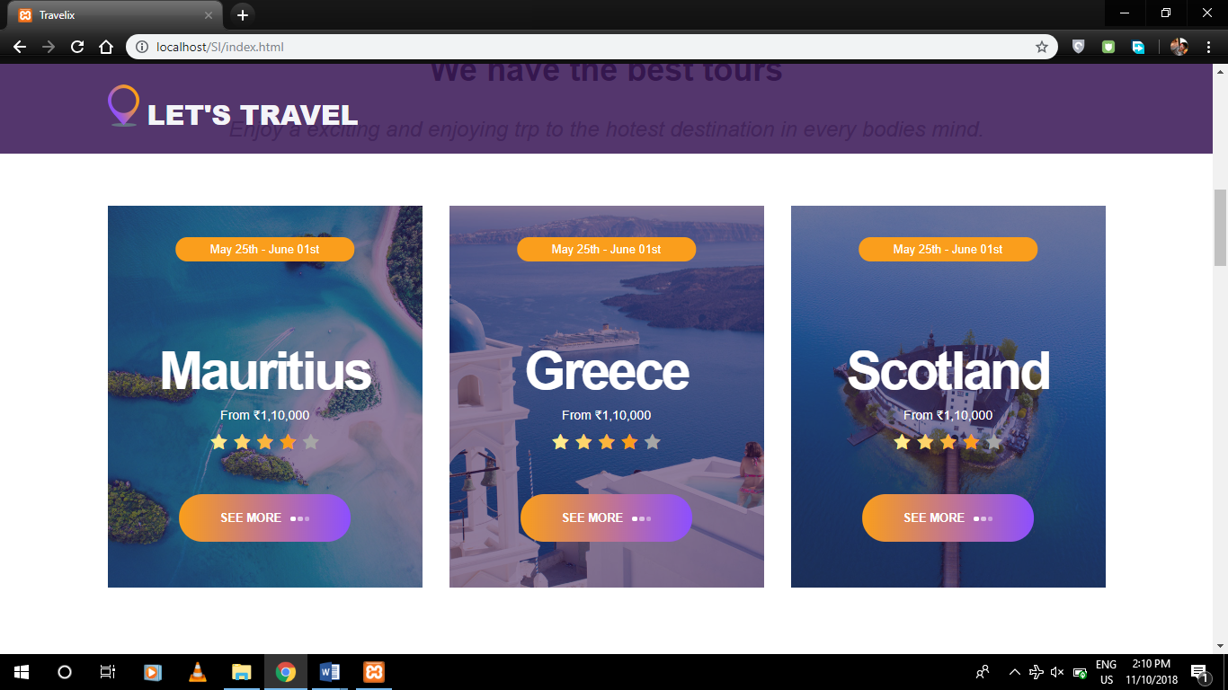

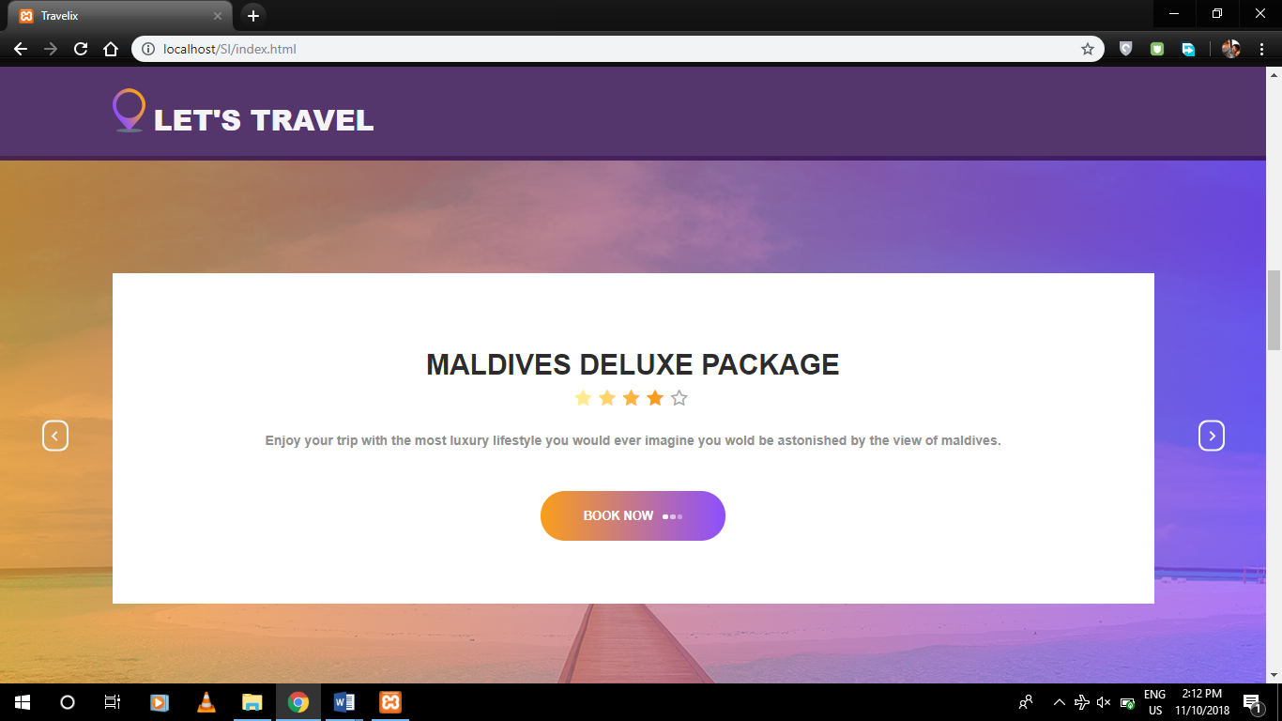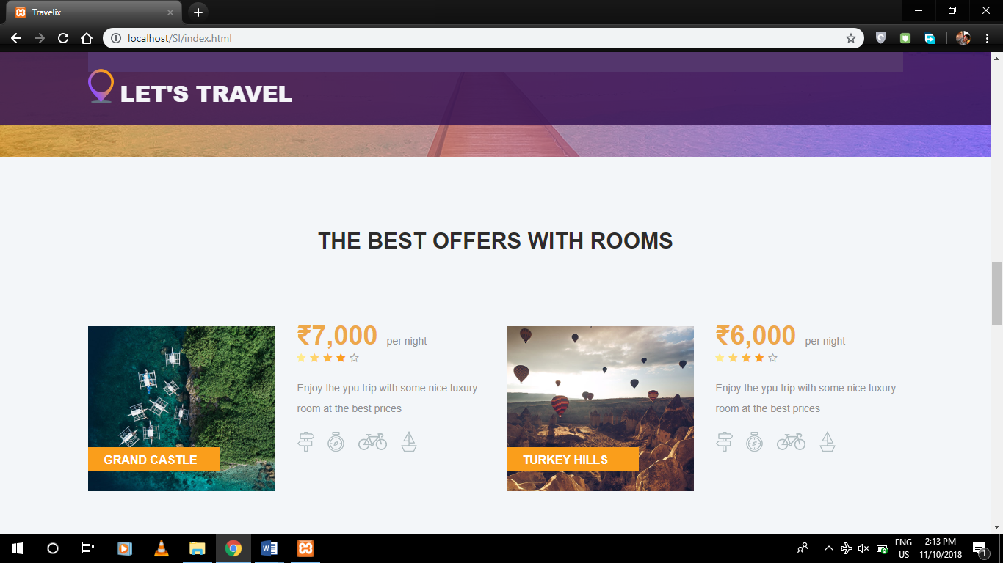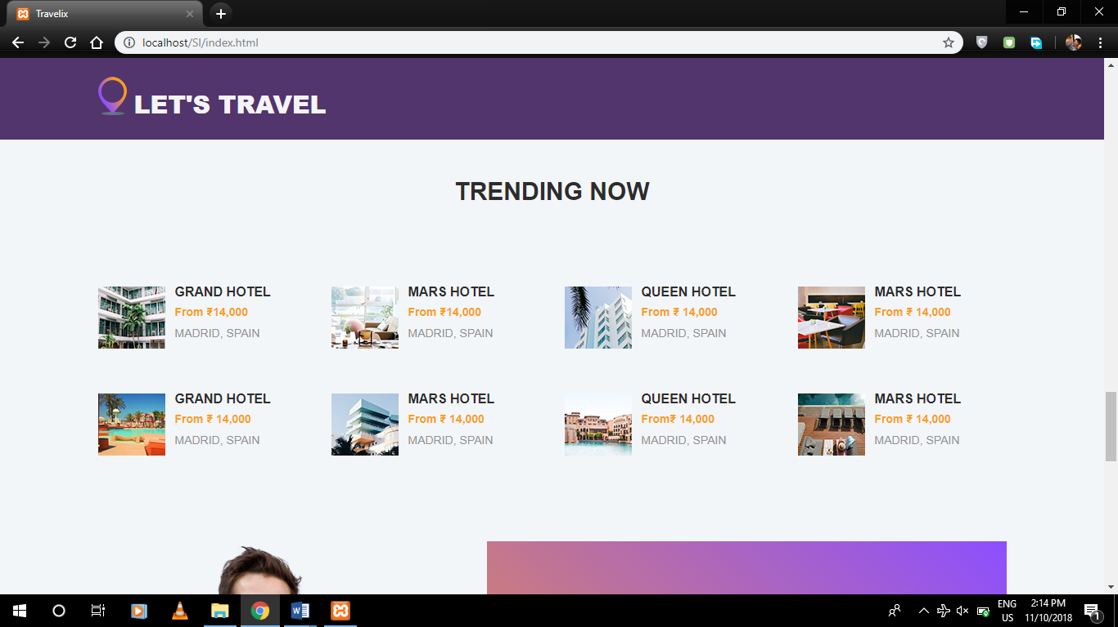 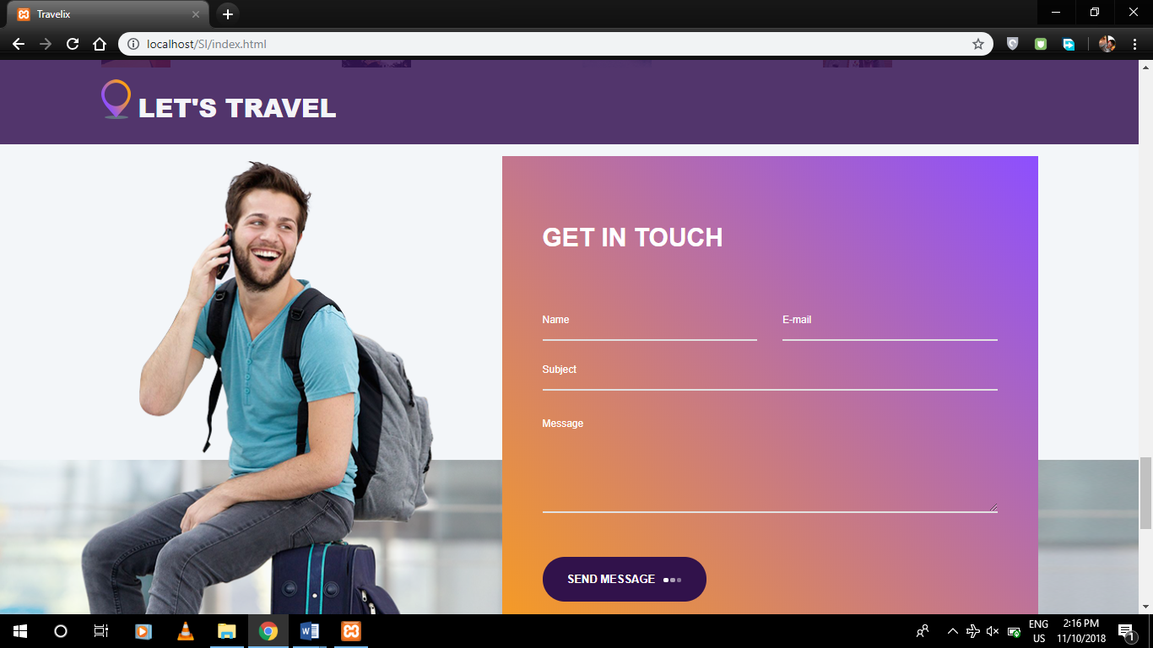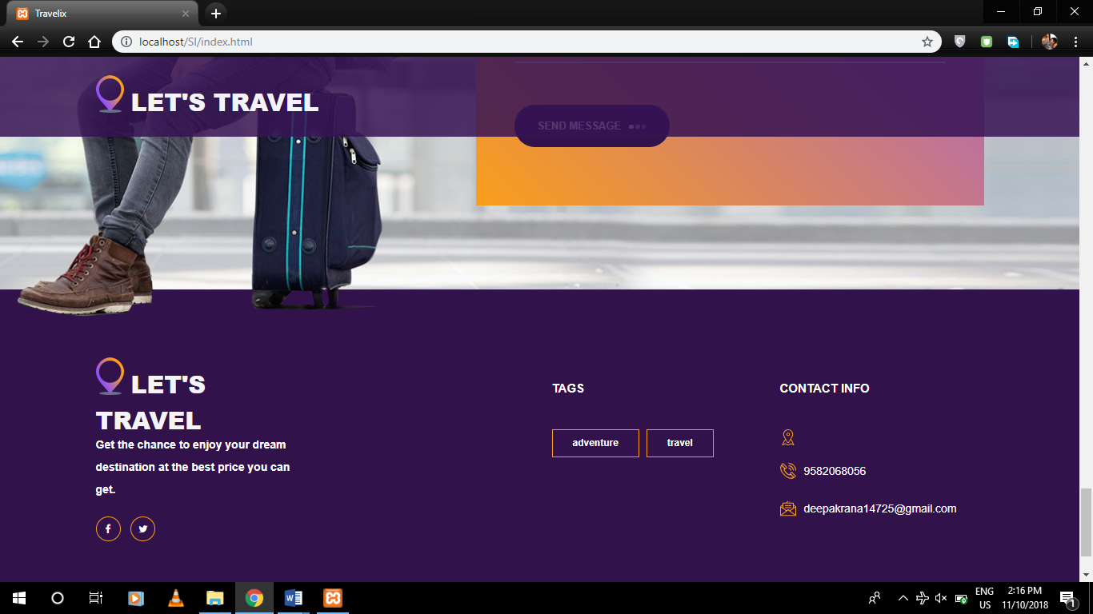

This is the front look of our Web-Site having an interlink with many other similar web pages containing important information related to product catalogue along with cart.

The portal of Travelix consist of Car rental, Best deals, Famous tourist places, Form to mail us(get in touch) etc.

It allows user to register departure and arrival places and send it through email to the web master. It also insures the customers to contact directly to Web master via phone calls or emails for their demands.

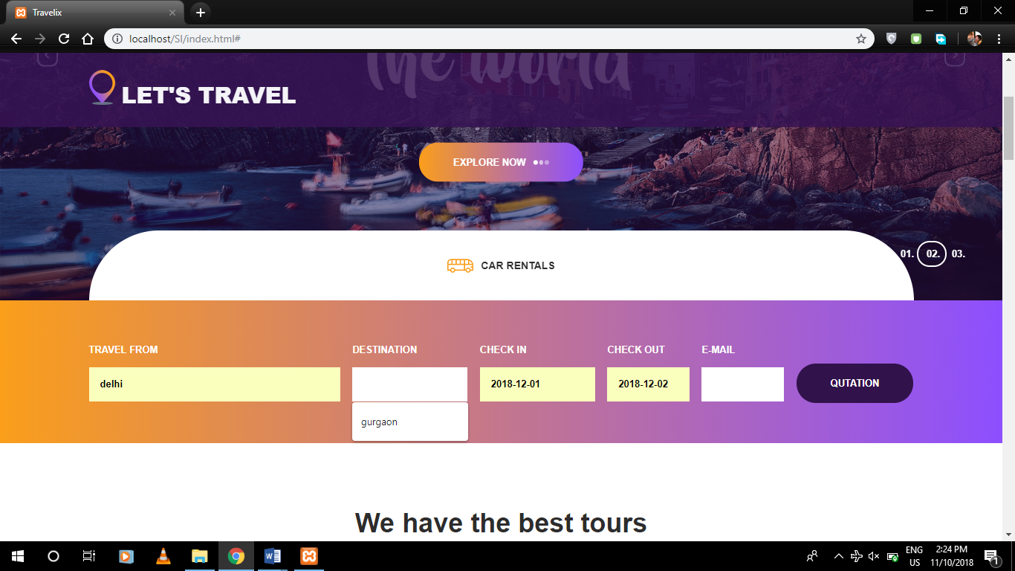

OR

The Users can easily contact or send mails to report any alerts and needs.

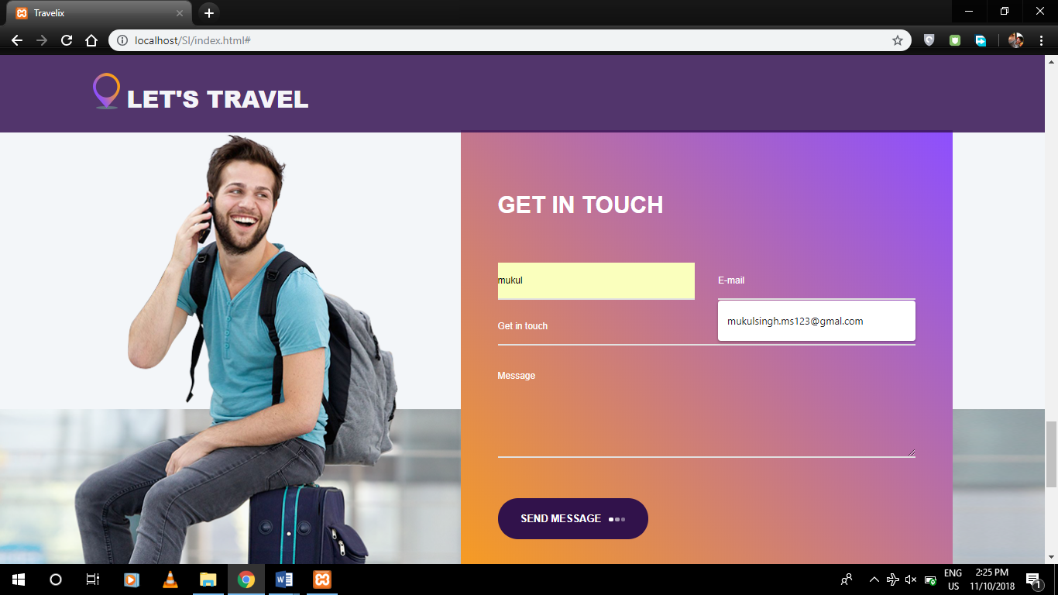

A very simple method to get in touch. Which also response if the reques was sent successfully.

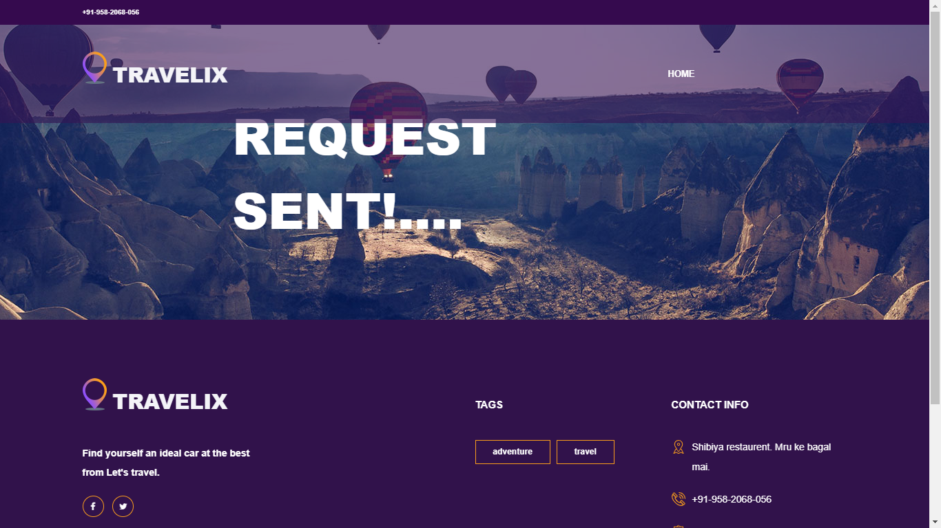

**Web Source Code(Index.html):**

<!DOCTYPE html>

<html lang="en">

<head>

<title>Travelix</title>

<meta charset="utf-8">

<meta http-equiv="X-UA-Compatible" content="IE=edge">

<meta name="description" content="Travelix Project">

<meta name="viewport" content="width=device-width, initial-scale=1">

<link rel="stylesheet" type="text/css" href="styles/bootstrap4/bootstrap.min.css">

<link href="plugins/font-awesome-4.7.0/css/font-awesome.min.css" rel="stylesheet" type="text/css">

<link rel="stylesheet" type="text/css" href="plugins/OwlCarousel2-2.2.1/owl.carousel.css">

<link rel="stylesheet" type="text/css" href="plugins/OwlCarousel2-2.2.1/owl.theme.default.css">

<link rel="stylesheet" type="text/css" href="plugins/OwlCarousel2-2.2.1/animate.css">

<link rel="stylesheet" type="text/css" href="styles/main_styles.css">

<link rel="stylesheet" type="text/css" href="styles/responsive.css">

</head>

<body>

<div class="super_container">

<!-- Header -->

<header class="header">

<!-- Top Bar -->

<div class="top_bar">

<div class="container">

<div class="row">

<div class="col d-flex flex-row">

<div class="phone">+91 9582068056</div>

<div class="social">

<ul class="social_list">

<li class="social_list_item"><a href="#"><i class="fa fa-facebook" aria-hidden="true"></i></a></li>

<li class="social_list_item"><a href="#"><i class="fa fa-twitter" aria-hidden="true"></i></a></li>

</ul>

</div>

</div>

</div>

</div>

</div>

<!-- Main Navigation -->

<nav class="main_nav">

<div class="container">

<div class="row">

<div class="col main_nav_col d-flex flex-row align-items-center justify-content-start">

<div class="logo_container">

<div class="logo"><a href="#"><img src="images/logo.png" alt="">Let's travel</a></div>

</div>

<div class="main_nav_container ml-auto">

</header>

<div class="menu trans_500">

<div class="menu_content d-flex flex-column align-items-center justify-content-center text-center">

<div class="menu_close_container"><div class="menu_close"></div></div>

<div class="logo menu_logo"><a href="#"><img src="images/logo.png" alt=""></a></div>

<ul>

<li class="menu_item"><a href="#">home</a></li>

</ul>

</div>

</div>

<!-- Home -->

<div class="home">

<!-- Home Slider -->

<div class="home_slider_container">

<div class="owl-carousel owl-theme home_slider">

<!-- Slider Item -->

<div class="owl-item home_slider_item">

<!-- Image by https://unsplash.com/@anikindimitry -->

<div class="home_slider_background" style="background-image:url(images/home_slider.jpg)"></div>

<div class="home_slider_content text-center">

<div class="home_slider_content_inner" data-animation-in="flipInX" data-animation-out="animate-out fadeOut">

<h1>discover</h1>

<h1>the world</h1>

<div class="button home_slider_button"><div class="button_bcg"></div><a href="#">explore now<span></span><span></span><span></span></a></div>

</div>

</div>

</div>

<!-- Slider Item -->

<div class="owl-item home_slider_item">

<div class="home_slider_background" style="background-image:url(images/home_slider.jpg)"></div>

<div class="home_slider_content text-center">

<div class="home_slider_content_inner" data-animation-in="flipInX" data-animation-out="animate-out fadeOut">

<h1>discover</h1>

<h1>the world</h1>

<div class="button home_slider_button"><div class="button_bcg"></div><a href="#">explore now<span></span><span></span><span></span></a></div>

</div>

</div>

</div>

<!-- Slider Item -->

<div class="owl-item home_slider_item">

<div class="home_slider_background" style="background-image:url(images/home_slider.jpg)"></div>

<div class="home_slider_content text-center">

<div class="home_slider_content_inner" data-animation-in="flipInX" data-animation-out="animate-out fadeOut">

<h1>discover</h1>

<h1>the world</h1>

<div class="button home_slider_button"><div class="button_bcg"></div><a href="#">explore now<span></span><span></span><span></span></a></div>

</div>

</div>

</div>

</div>

<!-- Home Slider Nav - Prev -->

<div class="home_slider_nav home_slider_prev">

<svg version="1.1" id="Layer_2" xmlns="http://www.w3.org/2000/svg" xmlns:xlink="http://www.w3.org/1999/xlink" x="0px" y="0px"

width="28px" height="33px" viewBox="0 0 28 33" enable-background="new 0 0 28 33" xml:space="preserve">

<defs>

<linearGradient id='home_grad_prev'>

<stop offset='0%' stop-color='#fa9e1b'/>

<stop offset='100%' stop-color='#8d4fff'/>

</linearGradient>

</defs>

<path class="nav_path" fill="#F3F6F9" d="M19,0H9C4.029,0,0,4.029,0,9v15c0,4.971,4.029,9,9,9h10c4.97,0,9-4.029,9-9V9C28,4.029,23.97,0,19,0z

M26,23.091C26,27.459,22.545,31,18.285,31H9.714C5.454,31,2,27.459,2,23.091V9.909C2,5.541,5.454,2,9.714,2h8.571

C22.545,2,26,5.541,26,9.909V23.091z"/>

<polygon class="nav_arrow" fill="#F3F6F9" points="15.044,22.222 16.377,20.888 12.374,16.885 16.377,12.882 15.044,11.55 9.708,16.885 11.04,18.219

11.042,18.219 "/>

</svg>

</div>

<!-- Home Slider Nav - Next -->

<div class="home_slider_nav home_slider_next">

<svg version="1.1" id="Layer_3" xmlns="http://www.w3.org/2000/svg" xmlns:xlink="http://www.w3.org/1999/xlink" x="0px" y="0px"

width="28px" height="33px" viewBox="0 0 28 33" enable-background="new 0 0 28 33" xml:space="preserve">

<defs>

<linearGradient id='home_grad_next'>

<stop offset='0%' stop-color='#fa9e1b'/>

<stop offset='100%' stop-color='#8d4fff'/>

</linearGradient>

</defs>

<path class="nav_path" fill="#F3F6F9" d="M19,0H9C4.029,0,0,4.029,0,9v15c0,4.971,4.029,9,9,9h10c4.97,0,9-4.029,9-9V9C28,4.029,23.97,0,19,0z

M26,23.091C26,27.459,22.545,31,18.285,31H9.714C5.454,31,2,27.459,2,23.091V9.909C2,5.541,5.454,2,9.714,2h8.571

C22.545,2,26,5.541,26,9.909V23.091z"/>

<polygon class="nav_arrow" fill="#F3F6F9" points="13.044,11.551 11.71,12.885 15.714,16.888 11.71,20.891 13.044,22.224 18.379,16.888 17.048,15.554

17.046,15.554 "/>

</svg>

</div>

<!-- Home Slider Dots -->

<div class="home_slider_dots">

<ul id="home_slider_custom_dots" class="home_slider_custom_dots">

<li class="home_slider_custom_dot active"><div></div>01.</li>

<li class="home_slider_custom_dot"><div></div>02.</li>

<li class="home_slider_custom_dot"><div></div>03.</li>

</ul>

</div>

</div>

</div>

<!-- Search -->

<div class="search">

<!-- Search Contents -->

<div class="container fill_height">

<div class="row fill_height">

<div class="col fill_height">

<!-- Search Tabs -->

<div class="search_tabs_container">

<div class="search_tabs d-flex flex-lg-row flex-column align-items-lg-center align-items-start justify-content-lg-between justify-content-start">

<div class="search_tab d-flex flex-row align-items-center justify-content-lg-center justify-content-start"><img src="images/bus.png" alt="">car rentals</div>

</div>

</div>

<!-- Search Panel -->

<div class="search_panel active">

<form action="mail.php" id="search_form_1" class="search_panel_content d-flex flex-lg-row flex-column align-items-lg-center align-items-start justify-content-lg-between justify-content-start" >

<div class="search_item">

<div>Travel from</div>

<input name="from" type="text" class="destination search_input" >

</div>

<div class="search_item">

<div>destination</div>

<input type="text" name="destination" class="destination search_input" >

</div>

<div class="search_item">

<div>check in</div>

<input type="text" name="check_in" class="check_in search_input" placeholder="YYYY-MM-DD">

</div>

<div class="search_item">

<div>check out</div>

<input type="text" name="check_out" class="check_out search_input" placeholder="YYYY-MM-DD">

</div>

<div class="search_item">

<div>E-mail</div>

<input type="text" name="Email" class="destination search_input" >

</div>

<button type="submit" class="button search_button">Qutation</button>

</form>

</div>

</div>

</div>

</div>

</div>

<!-- Intro -->

<div class="intro">

<div class="container">

<div class="row">

<div class="col">

<h2 class="intro_title text-center">We have the best tours</h2>

</div>

</div>

<div class="row">

<div class="col-lg-10 offset-lg-1">

<div class="intro_text text-center">

<p>Enjoy a exciting and enjoying trp to the hotest destination in every bodies mind. </p>

</div>

</div>

</div>

<div class="row intro_items">

<!-- Intro Item -->

<div class="col-lg-4 intro_col">

<div class="intro_item">

<div class="intro_item_overlay"></div>

<!-- Image by https://unsplash.com/@dnevozhai -->

<div class="intro_item_background" style="background-image:url(images/intro_1.jpg)"></div>

<div class="intro_item_content d-flex flex-column align-items-center justify-content-center">

<div class="intro_date">May 25th - June 01st</div>

<div class="button intro_button"><div class="button_bcg"></div><a href="#">see more<span></span><span></span><span></span></a></div>

<div class="intro_center text-center">

<h1>Mauritius</h1>

<div class="intro_price">From &#8377;1,10,000</div>

<div class="rating rating_4">

<i class="fa fa-star"></i>

<i class="fa fa-star"></i>

<i class="fa fa-star"></i>

<i class="fa fa-star"></i>

<i class="fa fa-star"></i>

</div>

</div>

</div>

</div>

</div>

<!-- Intro Item -->

<div class="col-lg-4 intro_col">

<div class="intro_item">

<div class="intro_item_overlay"></div>

<!-- Image by https://unsplash.com/@hellolightbulb -->

<div class="intro_item_background" style="background-image:url(images/intro_2.jpg)"></div>

<div class="intro_item_content d-flex flex-column align-items-center justify-content-center">

<div class="intro_date">May 25th - June 01st</div>

<div class="button intro_button"><div class="button_bcg"></div><a href="#">see more<span></span><span></span><span></span></a></div>

<div class="intro_center text-center">

<h1>Greece</h1>

<div class="intro_price">From &#8377;1,10,000</div>

<div class="rating rating_4">

<i class="fa fa-star"></i>

<i class="fa fa-star"></i>

<i class="fa fa-star"></i>

<i class="fa fa-star"></i>

<i class="fa fa-star"></i>

</div>

</div>

</div>

</div>

</div>

<!-- Intro Item -->

<div class="col-lg-4 intro_col">

<div class="intro_item">

<div class="intro_item_overlay"></div>

<!-- Image by https://unsplash.com/@willianjusten -->

<div class="intro_item_background" style="background-image:url(images/intro_3.jpg)"></div>

<div class="intro_item_content d-flex flex-column align-items-center justify-content-center">

<div class="intro_date">May 25th - June 01st</div>

<div class="button intro_button"><div class="button_bcg"></div><a href="#">see more<span></span><span></span><span></span></a></div>

<div class="intro_center text-center">

<h1>Scotland</h1>

<div class="intro_price">From &#8377;1,10,000</div>

<div class="rating rating_4">

<i class="fa fa-star"></i>

<i class="fa fa-star"></i>

<i class="fa fa-star"></i>

<i class="fa fa-star"></i>

<i class="fa fa-star"></i>

</div>

</div>

</div>

</div>

</div>

</div>

</div>

</div>

<!-- CTA -->

<div class="cta">

<!-- Image by https://unsplash.com/@thanni -->

<div class="cta_background" style="background-image:url(images/cta.jpg)"></div>

<div class="container">

<div class="row">

<div class="col">

<!-- CTA Slider -->

<div class="cta_slider_container">

<div class="owl-carousel owl-theme cta_slider">

<!-- CTA Slider Item -->

<div class="owl-item cta_item text-center">

<div class="cta_title">maldives deluxe package</div>

<div class="rating_r rating_r_4">

<i></i>

<i></i>

<i></i>

<i></i>

<i></i>

</div>

<p class="cta_text">Enjoy your trip with the most luxury lifestyle you would ever imagine you wold be astonished by the view of maldives.</p>

<div class="button cta_button"><div class="button_bcg"></div><a href="#">book now<span></span><span></span><span></span></a></div>

</div>

<!-- CTA Slider Item -->

<div class="owl-item cta_item text-center">

<div class="cta_title">maldives deluxe package</div>

<div class="rating_r rating_r_4">

<i></i>

<i></i>

<i></i>

<i></i>

<i></i>

</div>

<p class="cta_text">Enjoy your trip with the most luxury lifestyle you would ever imagine you wold be astonished by the view of maldives.</p>

<div class="button cta_button"><div class="button_bcg"></div><a href="#">book now<span></span><span></span><span></span></a></div>

</div>

<!-- CTA Slider Item -->

<div class="owl-item cta_item text-center">

<div class="cta_title">maldives deluxe package</div>

<div class="rating_r rating_r_4">

<i></i>

<i></i>

<i></i>

<i></i>

<i></i>

</div>

<p class="cta_text">Enjoy your trip with the most luxury lifestyle you would ever imagine you wold be astonished by the view of maldives.</p>

<div class="button cta_button"><div class="button_bcg"></div><a href="#">book now<span></span><span></span><span></span></a></div>

</div>

</div>

<!-- CTA Slider Nav - Prev -->

<div class="cta_slider_nav cta_slider_prev">

<svg version="1.1" id="Layer_4" xmlns="http://www.w3.org/2000/svg" xmlns:xlink="http://www.w3.org/1999/xlink" x="0px" y="0px"

width="28px" height="33px" viewBox="0 0 28 33" enable-background="new 0 0 28 33" xml:space="preserve">

<defs>

<linearGradient id='cta_grad_prev'>

<stop offset='0%' stop-color='#fa9e1b'/>

<stop offset='100%' stop-color='#8d4fff'/>

</linearGradient>

</defs>

<path class="nav_path" fill="#F3F6F9" d="M19,0H9C4.029,0,0,4.029,0,9v15c0,4.971,4.029,9,9,9h10c4.97,0,9-4.029,9-9V9C28,4.029,23.97,0,19,0z

M26,23.091C26,27.459,22.545,31,18.285,31H9.714C5.454,31,2,27.459,2,23.091V9.909C2,5.541,5.454,2,9.714,2h8.571

C22.545,2,26,5.541,26,9.909V23.091z"/>

<polygon class="nav_arrow" fill="#F3F6F9" points="15.044,22.222 16.377,20.888 12.374,16.885 16.377,12.882 15.044,11.55 9.708,16.885 11.04,18.219

11.042,18.219 "/>

</svg>

</div>

<!-- CTA Slider Nav - Next -->

<div class="cta_slider_nav cta_slider_next">

<svg version="1.1" id="Layer_5" xmlns="http://www.w3.org/2000/svg" xmlns:xlink="http://www.w3.org/1999/xlink" x="0px" y="0px"

width="28px" height="33px" viewBox="0 0 28 33" enable-background="new 0 0 28 33" xml:space="preserve">

<defs>

<linearGradient id='cta_grad_next'>

<stop offset='0%' stop-color='#fa9e1b'/>

<stop offset='100%' stop-color='#8d4fff'/>

</linearGradient>

</defs>

<path class="nav_path" fill="#F3F6F9" d="M19,0H9C4.029,0,0,4.029,0,9v15c0,4.971,4.029,9,9,9h10c4.97,0,9-4.029,9-9V9C28,4.029,23.97,0,19,0z

M26,23.091C26,27.459,22.545,31,18.285,31H9.714C5.454,31,2,27.459,2,23.091V9.909C2,5.541,5.454,2,9.714,2h8.571

C22.545,2,26,5.541,26,9.909V23.091z"/>

<polygon class="nav_arrow" fill="#F3F6F9" points="13.044,11.551 11.71,12.885 15.714,16.888 11.71,20.891 13.044,22.224 18.379,16.888 17.048,15.554

17.046,15.554 "/>

</svg>

</div>

</div>

</div>

</div>

</div>

</div>

<!-- Offers -->

<div class="offers">

<div class="container">

<div class="row">

<div class="col text-center">

<h2 class="section_title">the best offers with rooms</h2>

</div>

</div>

<div class="row offers_items">

<!-- Offers Item -->

<div class="col-lg-6 offers_col">

<div class="offers_item">

<div class="row">

<div class="col-lg-6">

<div class="offers_image_container">

<!-- Image by https://unsplash.com/@kensuarez -->

<div class="offers_image_background" style="background-image:url(images/offer_1.jpg)"></div>

<div class="offer_name"><a href="#">grand castle</a></div>

</div>

</div>

<div class="col-lg-6">

<div class="offers_content">

<div class="offers_price">&#8377;7,000<span>per night</span></div>

<div class="rating_r rating_r_4 offers_rating">

<i></i>

<i></i>

<i></i>

<i></i>

<i></i>

</div>

<p class="offers_text">Enjoy the ypu trip with some nice luxury room at the best prices</p>

<div class="offers_icons">

<ul class="offers_icons_list">

<li class="offers_icons_item"><img src="images/post.png" alt=""></li>

<li class="offers_icons_item"><img src="images/compass.png" alt=""></li>

<li class="offers_icons_item"><img src="images/bicycle.png" alt=""></li>

<li class="offers_icons_item"><img src="images/sailboat.png" alt=""></li>

</ul>

</div>

<div class="offers_link"></div>

</div>

</div>

</div>

</div>

</div>

<!-- Offers Item -->

<div class="col-lg-6 offers_col">

<div class="offers_item">

<div class="row">

<div class="col-lg-6">

<div class="offers_image_container">

<!-- Image by Egzon Bytyqi -->

<div class="offers_image_background" style="background-image:url(images/offer_2.jpg)"></div>

<div class="offer_name"><a href="#">turkey hills</a></div>

</div>

</div>

<div class="col-lg-6">

<div class="offers_content">

<div class="offers_price">&#8377;6,000<span>per night</span></div>

<div class="rating_r rating_r_4 offers_rating">

<i></i>

<i></i>

<i></i>

<i></i>

<i></i>

</div>

<p class="offers_text">Enjoy the ypu trip with some nice luxury room at the best prices</p>

<div class="offers_icons">

<ul class="offers_icons_list">

<li class="offers_icons_item"><img src="images/post.png" alt=""></li>

<li class="offers_icons_item"><img src="images/compass.png" alt=""></li>

<li class="offers_icons_item"><img src="images/bicycle.png" alt=""></li>

<li class="offers_icons_item"><img src="images/sailboat.png" alt=""></li>

</ul>

</div>

<div class="offers_link"></div>

</div>

</div>

</div>

</div>

</div>

<!-- Offers Item -->

<div class="col-lg-6 offers_col">

<div class="offers_item">

<div class="row">

<div class="col-lg-6">

<div class="offers_image_container">

<!-- Image by https://unsplash.com/@nevenkrcmarek -->

<div class="offers_image_background" style="background-image:url(images/offer_3.jpg)"></div>

<div class="offer_name"><a href="#">island dream</a></div>

</div>

</div>

<div class="col-lg-6">

<div class="offers_content">

<div class="offers_price">&#8377;7,000<span>per night</span></div>

<div class="rating_r rating_r_4 offers_rating">

<i></i>

<i></i>

<i></i>

<i></i>

<i></i>

</div>

<p class="offers_text">Enjoy the ypu trip with some nice luxury room at the best prices</p>

<div class="offers_icons">

<ul class="offers_icons_list">

<li class="offers_icons_item"><img src="images/post.png" alt=""></li>

<li class="offers_icons_item"><img src="images/compass.png" alt=""></li>

<li class="offers_icons_item"><img src="images/bicycle.png" alt=""></li>

<li class="offers_icons_item"><img src="images/sailboat.png" alt=""></li>

</ul>

</div>

<div class="offers_link"></div>

</div>

</div>

</div>

</div>

</div>

<!-- Offers Item -->

<div class="col-lg-6 offers_col">

<div class="offers_item">

<div class="row">

<div class="col-lg-6">

<div class="offers_image_container">

<!-- Image by https://unsplash.com/@mantashesthaven -->

<div class="offers_image_background" style="background-image:url(images/offer_4.jpg)"></div>

<div class="offer_name"><a href="#">travel light</a></div>

</div>

</div>

<div class="col-lg-6">

<div class="offers_content">

<div class="offers_price">&#8377;7000<span>per night</span></div>

<div class="rating_r rating_r_4 offers_rating">

<i></i>

<i></i>

<i></i>

<i></i>

<i></i>

</div>

<p class="offers_text">Enjoy the ypu trip with some nice luxury room at the best prices</p>

<div class="offers_icons">

<ul class="offers_icons_list">

<li class="offers_icons_item"><img src="images/post.png" alt=""></li>

<li class="offers_icons_item"><img src="images/compass.png" alt=""></li>

<li class="offers_icons_item"><img src="images/bicycle.png" alt=""></li>

<li class="offers_icons_item"><img src="images/sailboat.png" alt=""></li>

</ul>

</div>

<div class="offers_link"></div>

</div>

</div>

</div>

</div>

</div>

</div>

</div>

<div class="trending">

<div class="container">

<div class="row">

<div class="col text-center">

<h2 class="section_title">trending now</h2>

</div>

</div>

<div class="row trending_container">

<!-- Trending Item -->

<div class="col-lg-3 col-sm-6">

<div class="trending_item clearfix">

<div class="trending_image"><img src="images/trend_1.png" alt="https://unsplash.com/@fransaraco"></div>

<div class="trending_content">

<div class="trending_title"><a href="#">grand hotel</a></div>

<div class="trending_price">From &#8377;14,000</div>

<div class="trending_location">madrid, spain</div>

</div>

</div>

</div>

<!-- Trending Item -->

<div class="col-lg-3 col-sm-6">

<div class="trending_item clearfix">

<div class="trending_image"><img src="images/trend_2.png" alt="https://unsplash.com/@grovemade"></div>

<div class="trending_content">

<div class="trending_title"><a href="#">mars hotel</a></div>

<div class="trending_price">From &#8377;14,000</div>

<div class="trending_location">madrid, spain</div>

</div>

</div>

</div>

<!-- Trending Item -->

<div class="col-lg-3 col-sm-6">

<div class="trending_item clearfix">

<div class="trending_image"><img src="images/trend_3.png" alt="https://unsplash.com/@jbriscoe"></div>

<div class="trending_content">

<div class="trending_title"><a href="#">queen hotel</a></div>

<div class="trending_price">From &#8377; 14,000</div>

<div class="trending_location">madrid, spain</div>

</div>

</div>

</div>

<!-- Trending Item -->

<div class="col-lg-3 col-sm-6">

<div class="trending_item clearfix">

<div class="trending_image"><img src="images/trend_4.png" alt="https://unsplash.com/@oowgnuj"></div>

<div class="trending_content">

<div class="trending_title"><a href="#">mars hotel</a></div>

<div class="trending_price">From &#8377; 14,000</div>

<div class="trending_location">madrid, spain</div>

</div>

</div>

</div>

<!-- Trending Item -->

<div class="col-lg-3 col-sm-6">

<div class="trending_item clearfix">

<div class="trending_image"><img src="images/trend_5.png" alt="https://unsplash.com/@mindaugas"></div>

<div class="trending_content">

<div class="trending_title"><a href="#">grand hotel</a></div>

<div class="trending_price">From &#8377; 14,000</div>

<div class="trending_location">madrid, spain</div>

</div>

</div>

</div>

<!-- Trending Item -->

<div class="col-lg-3 col-sm-6">

<div class="trending_item clearfix">

<div class="trending_image"><img src="images/trend_6.png" alt="https://unsplash.com/@itsnwa"></div>

<div class="trending_content">

<div class="trending_title"><a href="#">mars hotel</a></div>

<div class="trending_price">From &#8377; 14,000</div>

<div class="trending_location">madrid, spain</div>

</div>

</div>

</div>

<!-- Trending Item -->

<div class="col-lg-3 col-sm-6">

<div class="trending_item clearfix">

<div class="trending_image"><img src="images/trend_7.png" alt="https://unsplash.com/@rktkn"></div>

<div class="trending_content">

<div class="trending_title"><a href="#">queen hotel</a></div>

<div class="trending_price">From&#8377; 14,000</div>

<div class="trending_location">madrid, spain</div>

</div>

</div>

</div>

<!-- Trending Item -->

<div class="col-lg-3 col-sm-6">

<div class="trending_item clearfix">

<div class="trending_image"><img src="images/trend_8.png" alt="https://unsplash.com/@thoughtcatalog"></div>

<div class="trending_content">

<div class="trending_title"><a href="#">mars hotel</a></div>

<div class="trending_price">From &#8377; 14,000</div>

<div class="trending_location">madrid, spain</div>

</div>

</div>

</div>

</div>

</div>

</div>

<div class="contact">

<div class="contact_background" style="background-image:url(images/contact.png)"></div>

<div class="container">

<div class="row">

<div class="col-lg-5">

<div class="contact_image">

</div>

</div>

<div class="col-lg-7">

<div class="contact_form_container">

<div class="contact_title">get in touch</div>

<form action="mail.php" id="contact_form" class="contact_form">

<input type="text" id="contact_form_name" class="contact_form_name input_field" placeholder="Name" required="required" data-error="Name is required.">

<input type="text" id="contact_form_email" class="contact_form_email input_field" placeholder="E-mail" required="required" data-error="Email is required.">

<input type="text" id="contact_form_subject" class="contact_form_subject input_field" placeholder="Subject" required="required" data-error="Subject is required.">

<textarea id="contact_form_message" class="text_field contact_form_message" name="message" rows="4" placeholder="Message" required="required" data-error="Please, write us a message."></textarea>

<button type="submit" id="form_submit_button" class="form_submit_button button">send message<span></span><span></span><span></span></button>

</form>

</div>

</div>

</div>

</div>

</div>

<!-- Footer -->

<footer class="footer">

<div class="container">

<div class="row">

<!-- Footer Column -->

<div class="col-lg-3 footer_column">

<div class="footer_col">

<div class="footer_content footer_about">

<div class="logo_container footer_logo">

<div class="logo"><a href="#"><img src="images/logo.png" alt="">Let's Travel</a></div>

</div>

<p class="footer_about_text">Get the chance to enjoy your dream destination at the best price you can get.</p>

<ul class="footer_social_list">

<li class="footer_social_item"><a href="#"><i class="fa fa-facebook-f"></i></a></li>

<li class="footer_social_item"><a href="#"><i class="fa fa-twitter"></i></a></li>

</ul>

</div>

</div>

</div>

<!-- Footer Column -->

<div class="col-lg-3 footer_column">

</div>

<!-- Footer Column -->

<div class="col-lg-3 footer_column">

<div class="footer_col">

<div class="footer_title">tags</div>

<div class="footer_content footer_tags">

<ul class="tags_list clearfix">

<li class="tag_item"><a href="#">adventure</a></li>

<li class="tag_item"><a href="#">travel</a></li>

</ul>

</div>

</div>

</div>

<!-- Footer Column -->

<div class="col-lg-3 footer_column">

<div class="footer_col">

<div class="footer_title">contact info</div>

<div class="footer_content footer_contact">

<ul class="contact_info_list">

<li class="contact_info_item d-flex flex-row">

<div><div class="contact_info_icon"><img src="images/placeholder.svg" alt=""></div></div>

</li>

<li class="contact_info_item d-flex flex-row">

<div><div class="contact_info_icon"><img src="images/phone-call.svg" alt=""></div></div>

<div class="contact_info_text">9582068056</div>

</li>

<li class="contact_info_item d-flex flex-row">

<div><div class="contact_info_icon"><img src="images/message.svg" alt=""></div></div>

<div class="contact_info_text"><a href="mailto:deepakrana14725@gmail.com?Subject=Hello" target="_top">deepakrana14725@gmail.com</a></div>

</li>

<li class="contact_info_item d-flex flex-row">

</li>

</ul>

</div>

</div>

</div>

</div>

</div>

</footer>

</div>

<script src="js/jquery-3.2.1.min.js"></script>

<script src="styles/bootstrap4/popper.js"></script>

<script src="styles/bootstrap4/bootstrap.min.js"></script>

<script src="plugins/OwlCarousel2-2.2.1/owl.carousel.js"></script>

<script src="plugins/easing/easing.js"></script>

<script src="js/custom.js"></script>

</body>

</html>

**Mail.php**

*<?php*

*$from = $_GET['from'];*

*$to = $_GET['destination'];*

*$on = $_GET['check_in'];*

*$till = $_GET['check_out'];*

*$name = $_GET['Email'];*

*$message= (" wants to go ").$to.(" from ").$from.(" during time period from ").$on.(" to ").$till;*

*$url = 'https://maker.ifttt.com/trigger/qutation/with/key/kp6iZZyhvMghG2JFYOVUKbmPe8_xoJy8Fl61z4YeDMC';*

*$ch = curl_init($url);*

*$xml = "value1=$name&value2=$message";*

*curl_setopt($ch, CURLOPT_POST, 1);*

*curl_setopt($ch, CURLOPT_POSTFIELDS, $xml);*

*$response = curl_exec($ch);*

*curl_close($ch);*

*header( 'Location: /notification.html' );*

*?>*

**Notificatin.html**

<!DOCTYPE html>

<html lang="en">

<head>

<title>Result</title>

<meta charset="utf-8">

<meta http-equiv="X-UA-Compatible" content="IE=edge">

<meta name="description" content="Travelix Project">

<meta name="viewport" content="width=device-width, initial-scale=1">

<link rel="stylesheet" type="text/css" href="styles/bootstrap4/bootstrap.min.css">

<link href="plugins/font-awesome-4.7.0/css/font-awesome.min.css" rel="stylesheet" type="text/css">

<link rel="stylesheet" type="text/css" href="styles/elements_styles.css">

<link rel="stylesheet" type="text/css" href="styles/elements_responsive.css">

</head>

<body>

<div class="super_container">

<!-- Header -->

<header class="header">

<!-- Top Bar -->

<div class="top_bar">

<div class="container">

<div class="row">

<div class="col d-flex flex-row">

<div class="phone">+91-958-2068-056</div>

<div class="social">

<ul class="social_list">

<li class="social_list_item"><a href="#"><i class="fa fa-facebook" aria-hidden="true"></i></a></li>

<li class="social_list_item"><a href="#"><i class="fa fa-twitter" aria-hidden="true"></i></a></li>

</ul>

</div>

</div>

</div>

</div>

</div>

<!-- Main Navigation -->

<nav class="main_nav">

<div class="container">

<div class="row">

<div class="col main_nav_col d-flex flex-row align-items-center justify-content-start">

<div class="logo_container">

<div class="logo"><a href="#"><img src="images/logo.png" alt="">travelix</a></div>

</div>

<div class="main_nav_container ml-auto">

<ul class="main_nav_list">

<li class="main_nav_item"><a href="index.html">home</a></li>

</ul>

</div>

<form id="search_form" class="search_form bez_1">

<input type="search" class="search_content_input bez_1">

</form>

<div class="hamburger">

<i class="fa fa-bars trans_200"></i>

</div>

</div>

</div>

</div>

</nav>

</header>

<!-- Home -->

<div class="home">

<div class="home_background parallax-window" data-parallax="scroll" data-image-src="images/about_background.jpg"></div>

<div class="home_content">

<div class="home_title">Request Sent!....</div>

</div>

</div>

<!-- Elements -->

<!-- Footer -->

<footer class="footer">

<div class="container">

<div class="row">

<!-- Footer Column -->

<div class="col-lg-3 footer_column">

<div class="footer_col">

<div class="footer_content footer_about">

<div class="logo_container footer_logo">

<div class="logo"><a href="#"><img src="images/logo.png" alt="">travelix</a></div>

</div>

<p class="footer_about_text">Find yourself an ideal car at the best from Let's travel.

</p>

<ul class="footer_social_list">

<li class="footer_social_item"><a href="#"><i class="fa fa-facebook-f"></i></a></li>

<li class="footer_social_item"><a href="#"><i class="fa fa-twitter"></i></a></li>

</ul>

</div>

</div>

</div>

<!-- Footer Column -->

<div class="col-lg-3 footer_column">

<div class="footer_col">

</div>

</div>

<!-- Footer Column -->

<div class="col-lg-3 footer_column">

<div class="footer_col">

<div class="footer_title">tags</div>

<div class="footer_content footer_tags">

<ul class="tags_list clearfix">

<li class="tag_item"><a href="#">adventure</a></li>

<li class="tag_item"><a href="#">travel</a></li>

</ul>

</div>

</div>

</div>

<!-- Footer Column -->

<div class="col-lg-3 footer_column">

<div class="footer_col">

<div class="footer_title">contact info</div>

<div class="footer_content footer_contact">

<ul class="contact_info_list">

<li class="contact_info_item d-flex flex-row">

<div><div class="contact_info_icon"><img src="images/placeholder.svg" alt=""></div></div>

<div class="contact_info_text">Shibiya restaurent. Mru ke bagal mai.</div>

</li>

<li class="contact_info_item d-flex flex-row">

<div><div class="contact_info_icon"><img src="images/phone-call.svg" alt=""></div></div>

<div class="contact_info_text">+91-958-2068-056</div>

</li>

<li class="contact_info_item d-flex flex-row">

<div><div class="contact_info_icon"><img src="images/message.svg" alt=""></div></div>

<div class="contact_info_text"><a href="mailto:contactme@gmail.com?Subject=Hello" target="_top">deepakrana14725@gmail.com</a></div>

</li>

<li class="contact_info_item d-flex flex-row">

</li>

</ul>

</div>

</div>

</div>

</div>

</div>

</footer>

<!-- Copyright -->

<div class="copyright">

<div class="container">

<div class="row">

<div class="col-lg-3 order-lg-1 order-2 ">

<div class="copyright_content d-flex flex-row align-items-center">

<div><!-- Link back to Colorlib can't be removed. Template is licensed under CC BY 3.0. -->

Copyright &copy;<script>document.write(new Date().getFullYear());</script> All rights reserved | This template is made with <i class="fa fa-heart-o" aria-hidden="true"></i> by <a href="https://colorlib.com" target="_blank">Colorlib</a>

<!-- Link back to Colorlib can't be removed. Template is licensed under CC BY 3.0. --></div>

</div>

</div>

<div class="col-lg-9 order-lg-2 order-1">

<div class="footer_nav_container d-flex flex-row align-items-center justify-content-lg-end">

<div class="footer_nav">

<ul class="footer_nav_list">

<li class="footer_nav_item"><a href="index.html">home</a></li>

<li class="footer_nav_item"><a href="about.html">about us</a></li>

<li class="footer_nav_item"><a href="offers.html">offers</a></li>

<li class="footer_nav_item"><a href="blog.html">news</a></li>

<li class="footer_nav_item"><a href="#">contact</a></li>

</ul>

</div>

</div>

</div>

</div>

</div>

</div>

</div>

<script src="js/jquery-3.2.1.min.js"></script>

<script src="styles/bootstrap4/popper.js"></script>

<script src="styles/bootstrap4/bootstrap.min.js"></script>

<script src="plugins/greensock/TweenMax.min.js"></script>

<script src="plugins/greensock/TimelineMax.min.js"></script>

<script src="plugins/scrollmagic/ScrollMagic.min.js"></script>

<script src="plugins/greensock/animation.gsap.min.js"></script>

<script src="plugins/greensock/ScrollToPlugin.min.js"></script>

<script src="plugins/progressbar/progressbar.min.js"></script>

<script src="plugins/jquery-circle-progress-1.2.2/circle-progress.js"></script>

<script src="plugins/parallax-js-master/parallax.min.js"></script>

<script src="js/elements_custom.js"></script>

</body>

</html>